**RETAIL STORE STOCK INVENTORY ANALYTICS**

**ABSTRACT**

Inventory is usually the most important operational activities of wholesale and retail business. Maintaining the inventory collectively suggests that keeping tab on the realizable value of all the stocks. This paper digs into the challenges of manual inventory management for wholesale and retail business and derives solutions to these challenges by designing an inventory management system with predictive analytics to order and update the stocks. The findings show the challenges facing the manual system of inventory management which is mostly done by keeping book records; the manual system requires everyday counting of items in the inventory, human errors are very prevalent during counting and recording. Based on the findings this paper highlights the possible solutions to the above problems; a computerized inventory management system to order and update the stocks was designed and goods were supplied to implement the possible solutions. The objective of this project is twofold. First, it proposes an analytic model for hospital inventory management commodities, which would be able to predict the future demands of various inventory commodities. The model takes into account previous demand, population and geographic Location and other factors to successfully predict the future demand. Second, the project suggests an optimization model that would minimize the cost involved in supply chain &amp; logistics management so that the required commodities can be made available to the hospitals at the minimum possible cost.

As inventory management deals with huge volume and different varieties of information which seems very complex to handle in the daily basis. Inventory stock should be modified or updated based on the customer retention which changes continues with the change in demand which also adds value to the organization in profits by avoiding wastages in the stock. To update the stock data in the organization one should keep on track with the end user demand time to time which can be done by keep track on goods based on First in first out and Last in First Out stock.

**INTRODUCTION**

Inventory management can be a dangerous balancing act as businesses seek to avoid lost sales due to out of stock merchandise, and reduce the expense of overstocking the wrong product or over-ordering the wrong inventory. Another factor that makes inventory management a lot more challenging is that styles and trends never stay the same. Considering also that inventory management is one of the most important activities of wholesale and retail businesses, along with this process has come a dramatic increase in volumes of data which is a challenge to cope with. An inventory management system with predictive analytics can be developed to help wholesale and retail businesses maintain optimal levels of inventory and copy with sheer volumes of data in their businesses.

Some of the drawbacks of using big data analytics in the retail sector has raised concerns among the customers as well the retailers. Privacy concern is one of them. Customers feel that their privacy are being snatched away when retailers track their location or store their purchase information for targeting them with personalized advertisements. Although big data analytics help employees to fasten up their work, it also poses a high cost for managing such a huge amount of data. Software needed to sort and analyze these data are very expensive. On the other hand, requires skilled people to work with them. Data quality decreases because of automation of data gathering, sorting and analyzing them.

Some major advantages of using big data analytics in the retail sector are it saves costs, helps in product development, speeds up data management, helps in predicting future, helps in inventory management, helps in price management, helps in micro targeting customers, etc.

**RELATED WORKS**

There are few commercial solutions that attempt to help wholesale and retail business owners manage inventory optimally. IBM developed inventory management solutions that help organizations manage physical and virtual assets for peak profitability, reduce working capital requirements, identify the right physical inventory for your supply chain, determine optimal purchase levels to support production facilities, predict customer demand and align with inventory and production. Aptean, a global leader in enterprise application software provides enterprise software solutions developed Ross Inventory Analytics module with which you can accurately analyze inventory by product hierarchy (e.g., group, family, SKU), time, organizational unit (e.g., plant, warehouse), and other operational parameters .

Also, In regards to inventory management there several products on the market that have been developed by several companies that majorly help in tracking, managing inventory and cope with growing volumes of data in their businesses but they do not have the element of forecasting and predictive analytics. The most popular programs such as Fishbowl can be implemented as standalone systems to manage only inventory, Point of Sale (POS) suite, ware house management system (WMS). The core features minus predictive analytics include sorting items by department or type, establishing of thresholds for minimum quantities and alerts when stock levels reach those thresholds.

**METHODOLOGY**

This chapter discusses the research design that was used, population, sample size and sampling techniques, data collection instruments, and data analysis. The study population of this research comprised of employees from 8 businesses in Kampala, Uganda. The sample of the study consisted of 8 respondents; 2 store-keeper managers, 2 pharmacy attendants, 2 pump attendants at petrol stations and 2 managers of businesses. Out of 8 respondents, they were all interviewed and they gave responses except some that didn’t understand some questions. The researcher’s aim was to collect primary data by use of interviews covering the different aspects of inventory management; the questions included both open ended and closed ended question. Data collection procedure involved the researcher administering the questions to the respondents from the interview guide. The study generated both quantitative and qualitative data to explain the inventory management, how it works and ways to improve their inventory. The data collected was edited to remove errors and omissions and corrected where possible. Tools used for analysis was Microsoft Excel where we used descriptive analysis through coding to analyze qualitative data.

**EXISTING SYSTEM**

Inventory data management deals with large collection stock related data in the supply chain management environment. The frequency of data collection is very high in terms of stock volume. Content analysis management plays a vital role in managing the stock data in order to classify and cluster in terms managing the data. The process of data classification and clustering will keep track on the stock in order to fulfill the customer need on demand.

The inventory management with respect to supply chain management involves not only controlling the raw materials of stock as well the cost which is related to the stock in the supply chain environment. This process involves in verifying the demand on stock by making use of the concept first in first out(FIFO) and Last in First out(LIFO) techniques in order to verify the demand basis of end user which helps to control the wastages in stock in inventory Management.

The error rate and complexity of huge volume of data is very high. We need some techniques in order to prevent the issues which are directly related to the volume and variety of data in managing the stock information within an organization.

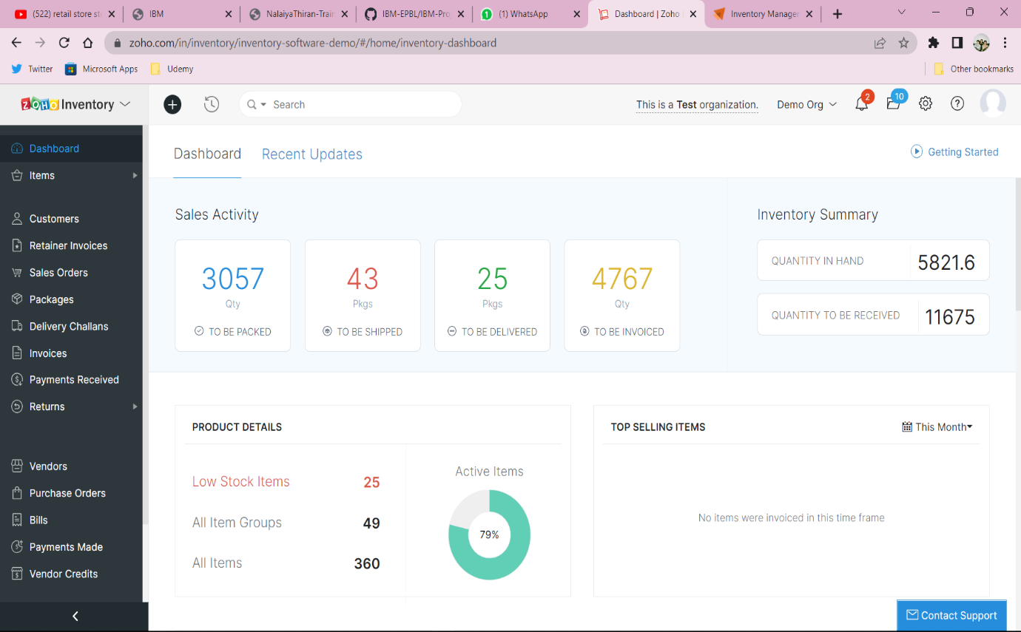

In this approach, supply chain management and inventory data management deals the huge assortment of data in terms of both volume and variety using different dimensions.

1. Data Classification

2. Data clustering

3. Content analysis

4. Customer retention

5. Inventory based on LIFO and FIFO.

Supply chain Management and inventory data management using big data analytics In inventory management, we support to marketing analysis which helps in identifying the stock with in demand with respect to the end user with the change in need. Based on this survey, we can update the stock management with respect to the time and situation of the end user. Analysis of data prediction is based on customer retention which directly related to the end user satisfaction rate.

The increase in data results not only in storage but also in analyzing and processing the flow of information in while classifying and clustering the data as per need. There we come up with a concept of content analysis and management which is major aspect in managing the stock within an organization with raised change in demand.

**CONCLUSION**

From the findings, the survey shows that inventory management is important aspects to the success of any whole sale and retail business since it was our focus of our survey. With growing trends and availability of technology solutions, most business owners have not embraced these solutions in their business processes to improve the way in which they operate to increase productivity, accountability and efficiency which increases their profit margin in the long run since operational costs and losses owing to uninformed decision making are reduced with tech-oriented solutions like a smart inventory management system.

**REFERENCES**

[1] Abramovitz & Modigliani, Franco (1957), “Business Reasons for Holding Inventories and Their Macro Economic Implications”, Problems of Capital Formation, Studies in Income and Wealth, Vol. 19, NBER, pp. 495-511.

[2] Anichebe, N. A. & Agu, O. A. (2013). Effect of Inventory Management on Organizational Effectiveness. Information and Knowledge Management, vol.3, iss.8, pp. 92 – 100.

[3] Chadda, R.S (1964), “Inventory Management in India”, Allied Publishers, Bombay, 1964.

[4] Capkun, Vedran, Hameri, Ari-Pekka & Weiss, Lawrence A. (2009). On the relationship between inventory and financial performance in manufacturing. International Journal of Operations & Production Management, vol.29, iss.8, pp.789–806.

[5] Edwin Sitienei, Florence Memba(2015-16) “ The Effect of Inventory Management on Profitability of Cement Manufacturing Companies in Kenya: A Case Study of Listed Cement Manufacturing Companies in Kenya” International Journal of Management and Commerce Innovations Vol. 3, Iss. 2, pp. 111- 119.

[6] Eneje, B. C., Nweze, A .U. & Udeh, A. (2012). Effect of Efficient Inventory Management on Profitability: Evidence from Selected Brewery Firms in Nigeria. International Journal of Current Research, vol.4, iss.11, pp.350-354.

[7] Gaur, Jighyasu & Bhattacharya, Sourabh. (2011). The relationship of financial and inventory performance of manufacturing firms in Indian context. California Journal of Operations Management, vol. 9, iss.2, pp.70–77

[8] Gaur, V., Fisher, M. & Raman, A. (2005).” An econometric analysis of inventory turnover performance in retail services”. Management Science, vol.5,iss.2, pp.181–194.

[9] George, P. V (1972), “Inventory Behaviour and Efficacy of Credit Control”, Anvesak, No.2, Vol.II, 1972, pp. 168-175. |

[10] Krishnamurty K., “Private Investment Behaviour in India: A Macro Time Series Study”, Arthaniti, January 1964.